Health Mania

4 – 8 players in teams of 2+
Ages 12 and up

In the game of Health Mania®, there is much to learn and unveil about what it is truly like to maintain a healthy lifestyle. Beginning as an obese individual at 500 lbs., travel around the game board with a partner and gain some unique, but essential knowledge on eating healthily and living right. You will venture upon four various tasks which include draw, act, “Fatman”, or trivia in order to win each challenge and reach the end of the game as a healthier and wiser person!

Object of the Game
- Be the first player to reach the healthy weight zone (135 – 155 lbs.) from the starting weight of 500 lbs. by winning enough challenges to reduce your weight.

Contents
- 1 game board
- 4 colorful pawns
- 1 dice
- 1 white board and marker
- Stack of Act, Draw, “Fatman”,
Trivia, and Chance cards

Setup
- Some preparation will be needed before you can begin the game. A scale for the “Fatman” portion of the game needs to be drawn onto the white board, using this template as a reference for any aspiring artists in the group:
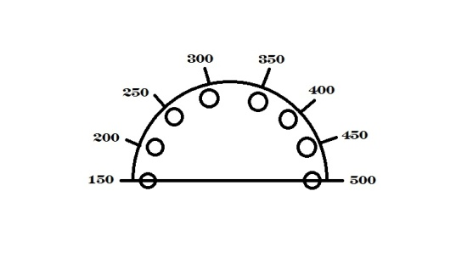
- Each wrong guess raises the weight of the Fatman by 50 lbs. For every correct guess, the weight remains the same. Use the circular magnet to keep track of the weight. You would have lost the challenge once you have reached the 500 lb. limit.

How to Play the Game
- The roll of the dice determines the order in which the teams will advance throughout the game.
- Each team will choose a different path from which to start. (Each path consists of more of one task than the other three, so choose wisely on where you want to start.)
- Each team begins the game at an unhealthy, dangerous 500 lbs. For each challenge won, either 10 or 20 lbs. can be subtracted from the current weight, bringing them closer to being healthy and winning the game.

Cards
Roll the dice for movement. A member of any opposing team can keep track of the 1 minute limit for the challenge with a watch or count to 60 seconds if no player has a watch.
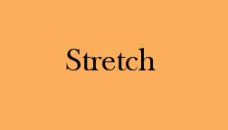
  - If you land on “A”, pick up an Act card and act out the word(s) written for your partner to guess in 1 minute.
  - If you land on “F”, pick up a Fatman card and have your partner guess letters of the word written.
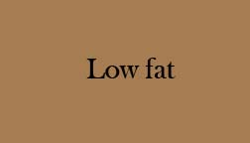
  - If you land on “D”, pick up a Draw card and draw the word written for your partner to guess in 1 minute.
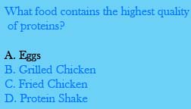
  - If you land on a “T”, pick up a trivia card and read question to your partner for him or her to answer in 1 minute.
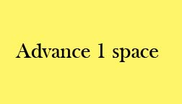
  - If you land on the purple mystery box, pick up a Chance card and do as it says.

How to Win the Game
- If you lose a challenge, return the card to the bottom of the deck. The turn goes to the next team.
- If you win a challenge, keep the card and subtract the number of pounds associated with the card from your current weight value.
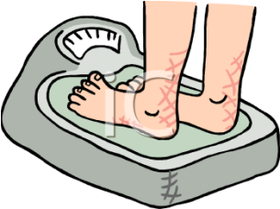
  - Act and Draw reward you with a 20 lb. loss
  - Trivia and “Fatman” reward you with a 10 lb. loss
- If a partner guesses or answers incorrectly when their 1 minute is up, the opposing teams have one chance to respond with the correct answer and steal the card. There is no penalty for incorrect guesses from the opposing team.
- If there are two players on one square, stay where you are and proceed as you normally would.
- Play as above until a team has reached a healthy weight within the range of
135 – 155 lbs.

ENJOY AND MAY THE HEALTHIEST AND STEALTHIEST WIN!

